Game: Name Pending
Marc Jones

Description:
- A blend of real time head-to-head class competition and study revision in one.
- Students will have to complete a series of minigames with the goal to increase their score higher than their peers (winner gets bragging rights!)
- These minigames could either be adaptable to a range of subjects using a customisable question pack or have pre-set questions made by the developers (us). Customisable questions would allow for more versatility. However, having a selection of already made questions would enrich the student experience greater.

Sketches:
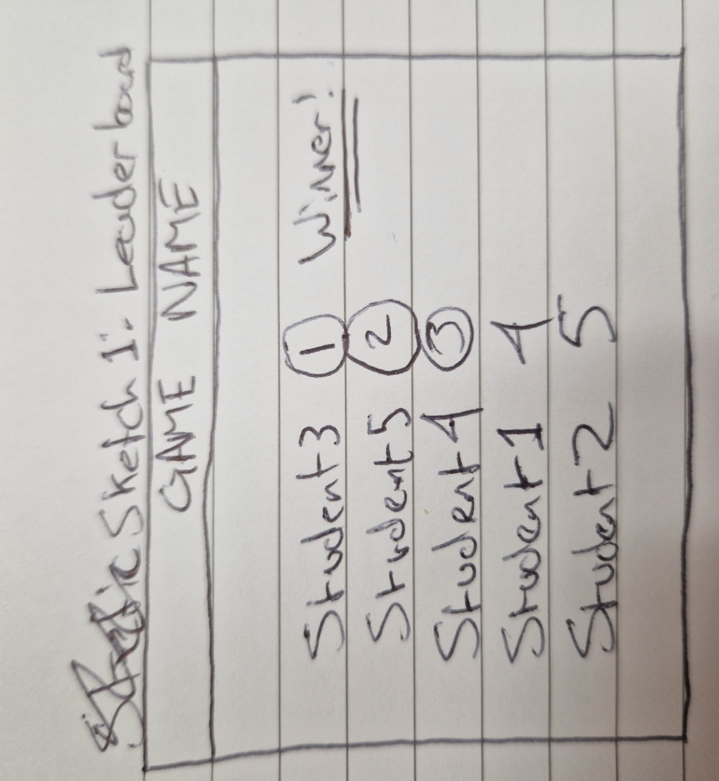
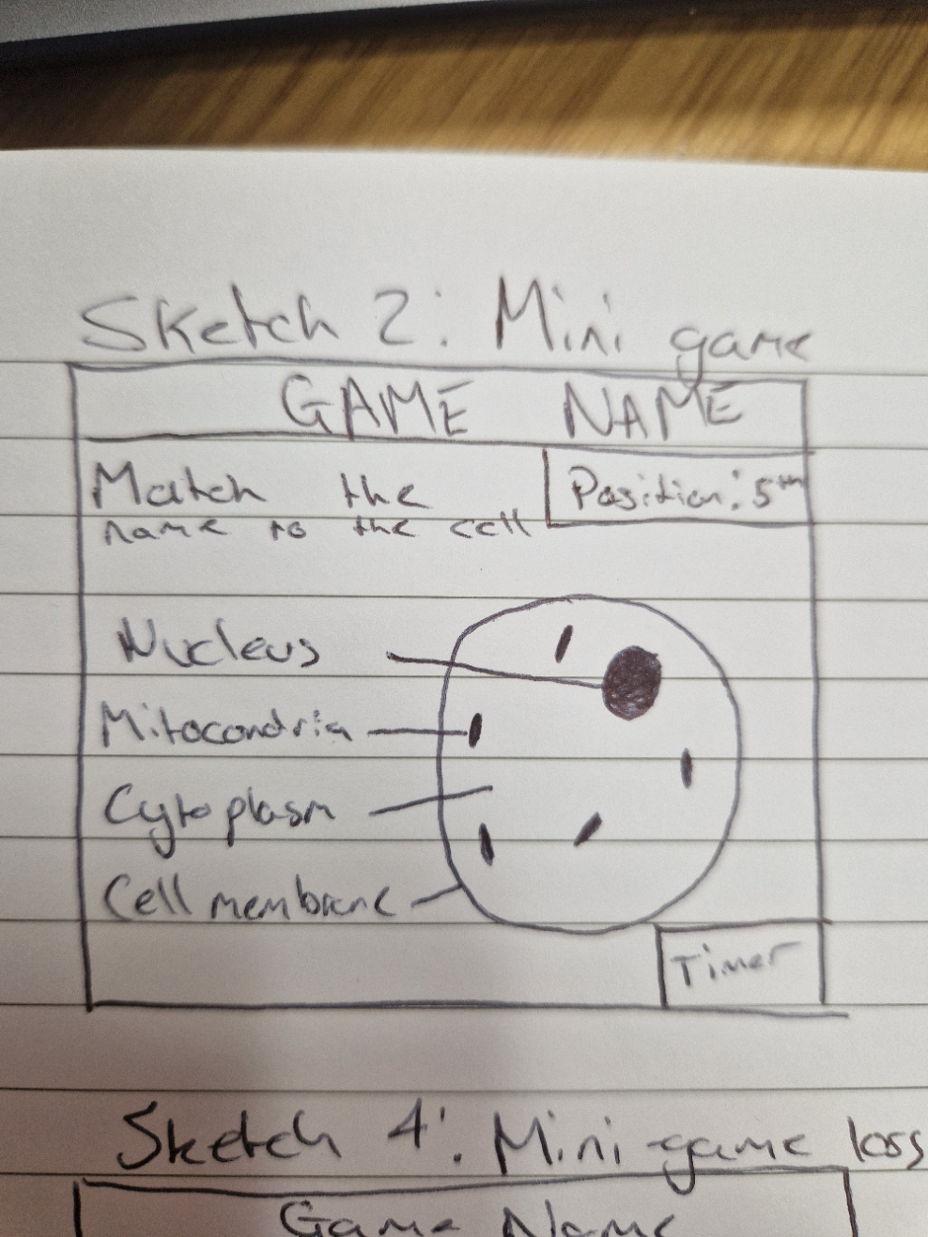
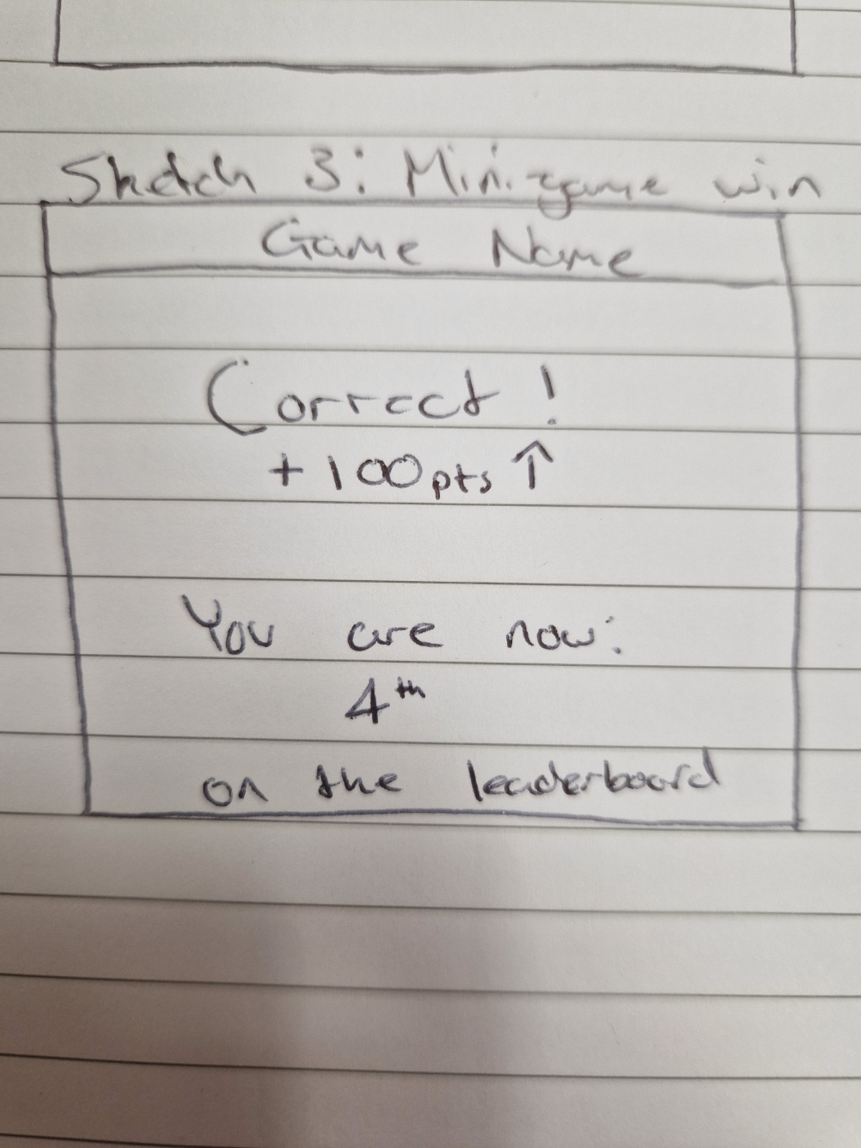
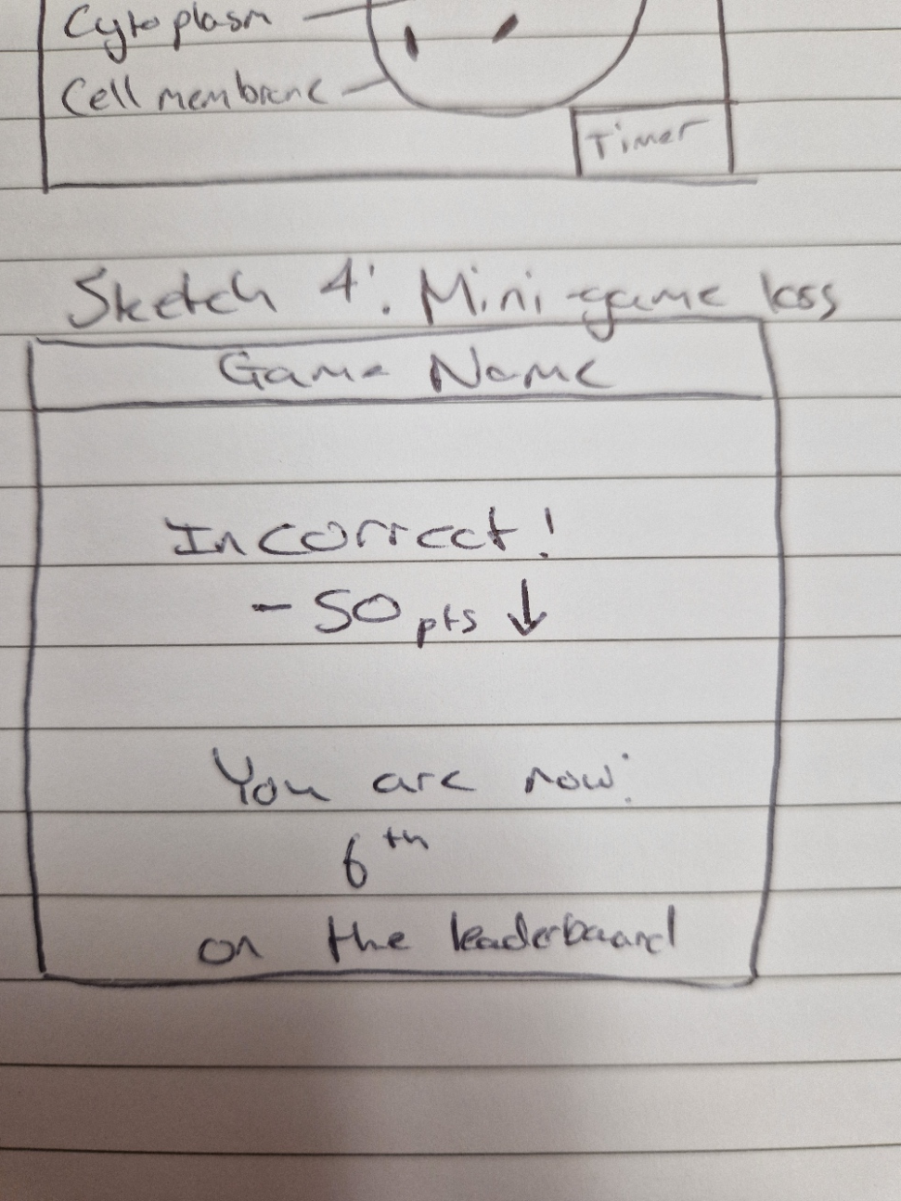

Highlights:
- Students are encouraged to revise in an engaging manner
- Questions will inevitably be repeated so it gives learners the opportunity to correct their mistakes and eventually end up getting 100% correct
- (idea) have the timer continuously get shorter as the game progresses, game ends when timer expires. Adds an extra layer of engagement and challenge. Will shake up each playthrough and increase the stakes.
- Including competition amongst peers will increase the desire to play more (and as such learn more)

Relations to existing games:

Inspiration 1: Kahoot

Question section:
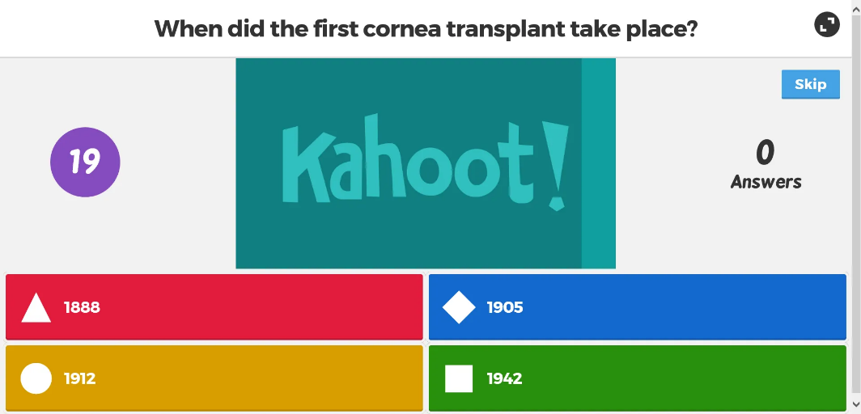

Leaderboard:
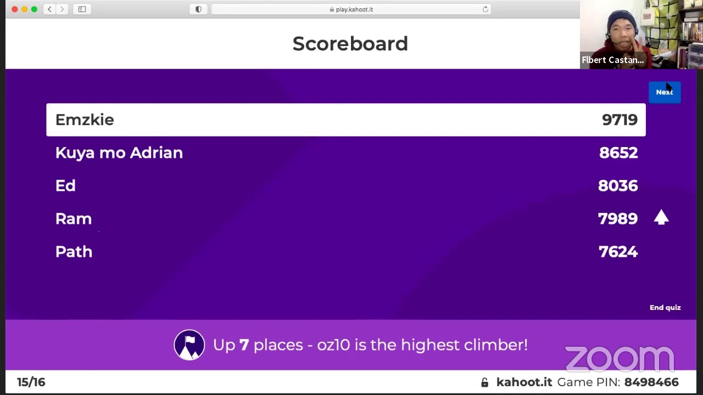

My main takeaways from Kahoot are the power of competing against your peers. From personal experience, this method of teaching students is extremely effective. You are easily able to gain the students attention and have them actually want to improve their knowledge. Students take a great level of satisfaction from learning more and beating their friends.

Inspiration 2: Bumb ways to die
Minigame 1:
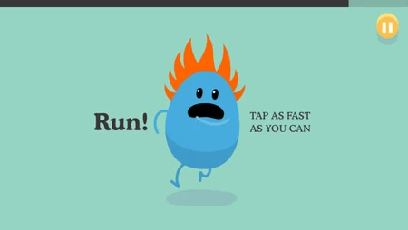

Minigame 2:
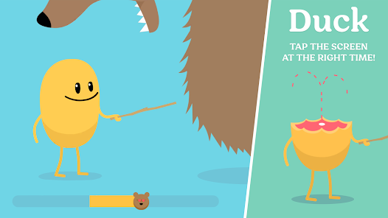

My current game idea follows a similar flow to the very popular game ‘dumb ways to die’. It follows a game loop of selecting a random minigame from a group, playing the minigame - with the goal of either completing an action before the timer expires (see minigame 1 where you have to put out the fire) or surviving until the timer expires (see minigame 2 where you have to avoid being eaten for the duration).

To apply this to the idea:
- Minigames would happen (i.e. building a electrical circuit) depending on the performance of the student,
- Student would pass or fail depending on the outcome
- Score is increased or decreased
- Next minigame would commence

